**Prototype Design Document**

## Introduction

The high fidelity prototype described in this document will be for a website that is tailored to car enthusiasts in the city of London. The concept of the website is to create a platform where car enthusiasts in London can post reviews of cars, pictures and videos of cars they see around, and find places in London to rent and try out cars of their interest. I decided to develop a website of this theme because I feel like it comes across as a good idea, useful and something that has not necessarily been done before. This document will thoroughly describe the prototype's design, highlighting the reasoning behind the selection of frameworks and libraries, as well as the implementation of key features to achieve an engaging and accessible web application.

## ***Prototype functionality***

My high fidelity prototype included vast range of functions and features, to properly simulate the functionality of the website, along with my unique feature.

My common feature of my website is a login system for a user. This feature included:

* An input box for the username: I used an input text box for the username section to allow the user type out their desired username, as they tend to have a lot of varied characters.
* An input box for the password: Just like the username input box, I used it because they tend to have a lot of varied characters and symbols.
* Validation techniques: Originally, when you pressed login without entering any data, the website would still let you in. I changed this by implementing simple validation that required the user to enter details, if not, they cannot enter the website.

The unique feature of the website is a system that allows the user to enter 5 ideal features or specifications of a car, and a car that matches their selections is recommended. A place in London to try out the car for a test drive is then provided. This feature included:

* An interactive map of London: Originally for my prototype, I only used an image to represent the map of London. After user testing from others they recommended I made this section interactive, to provide a proper experience of how it would actually be used in the website. I then replaced this with an interactive map that shows London, and would then enhance the user’s experience.
* An interactive calendar: Just like the map, I had originally used only an image. I feel replacing this with an actual interactive calendar would give a proper simulation to the user and whoever is using my prototype, how it would actually be on the website.
* A car option menu: This menu consists of 5 dropdowns: Type, Engine, Horsepower, Transmission and Drivetrain. Each dropdown has options to pick from, to prevent any errors with misspellings by the user and other complications.
* A car list view: This contains a list of cars that would meet the specifications provided by the user. I used pictures of the cars as well to show recognition rather than recall.
* A booking menu: This menu consists of detail input boxes for name, email and driver’s license number, and a dropdown for times available. The input boxes were used because those content types tend to have a lot of varied characters and symbols. A dropdown menu was used to show only the available times, and give the user options that they can pick from.
* A success page: This page shows up when the user has successfully booked their test drive, and shows them a confirmation message, saying the details will be forwarded to their email address. I included this so the user is assured that they have their booking.
* Validation techniques: This includes methods to stop the user from getting to the next page if they have not entered any details, or incorrectly entered details.

## ***Background technologies***

When developing my prototype, I used a variation of JavaScript libraries and CSS frameworks. This was to provide my prototype with more functionality, and properly mimic an interactive website. The JavaScript libraries I used were:

* FullCalendar: I used this library to display events and manage a calendar view in my prototype. My unique feature involved a booking system that requires you to select a date and time for your test drive, so I felt it would be ideal to incorporate this. The use of this makes the user’s experience generally easier and more interactive.
* Leaflet: I used this library to create an interactive map of London, and add a marker to indicate the specific location. My unique feature is tailored around users in London, and provides a test drive near their London location, so I knew it would be ideal to use this. Implementing this enhances the user’s web experience.

## ***Walkthroughs***

### **Login Page**

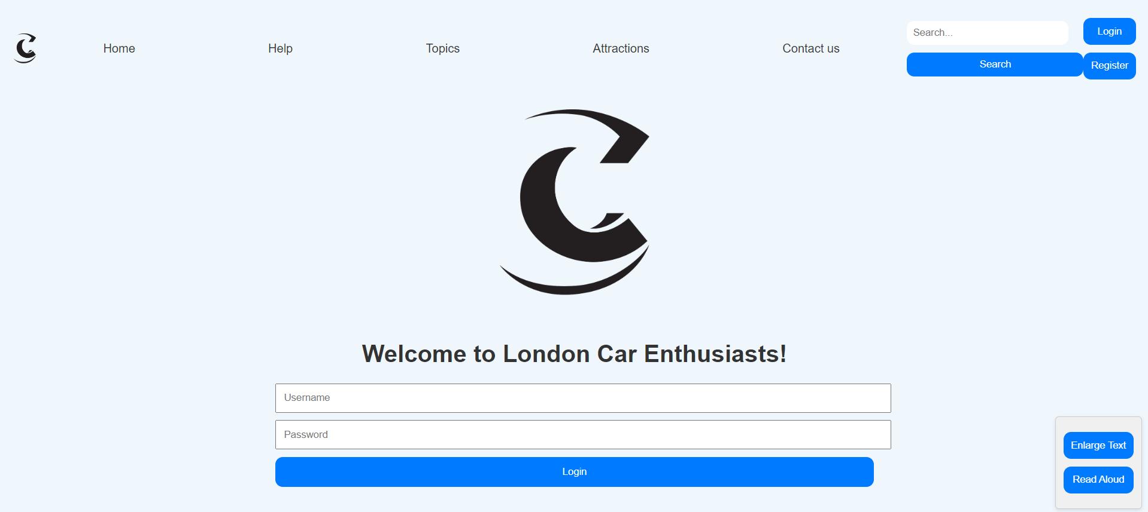

The login page is the first page you are greeted with, with a logo and a welcome message. You are then asked to login with your username and password. The design of the login page is simple and minimalistic, for easy use and focus towards the login.

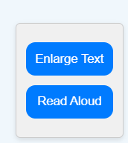

The prototype makes use of various accessibility features to accommodate for users with disabilities. The “Read Aloud” button begins to narrate the text on the website for the visually impaired, and the “Enlarge Text” button enlarges any text on the webpage.

As shown below, the text on the webpage enlarges once the button is pressed.

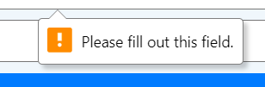The prototype also has validation techniques in the webpage, to prevent the user from proceeding to the next page. The user is greeted with this message if they do not enter any details. This is common throughout all the webpages in the prototype.

### **Home Page**

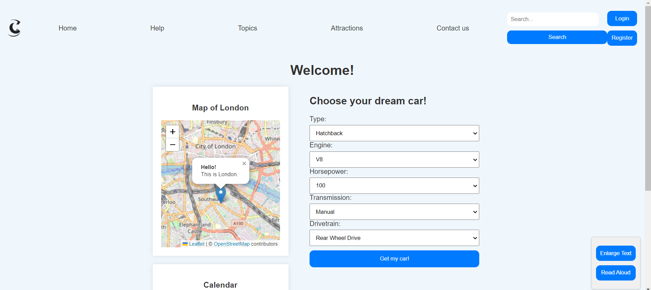

The home page is the second page you are greeted with, with a map, a calendar and a car menu. The toolbar and accessibility features are still present, to keep a consistent theme throughout the webpage.

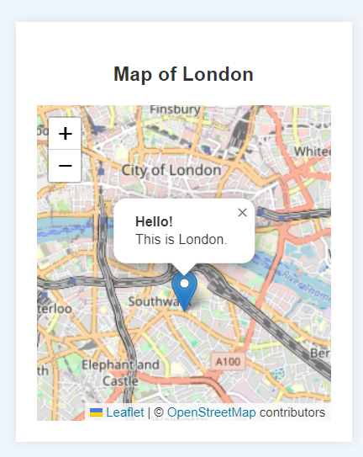 The webpage also contains an interactive map, that shows the area of London to the user. The user can then explore areas around London, and the map is then used to show the closest area near the user for their test drive after they book it.

The webpage then contains an interactive calendar that shows the current date, and can be used to book and add events. In this scenario, it is primarily used by the user to book the date of their test drive, and the available times are then shown.

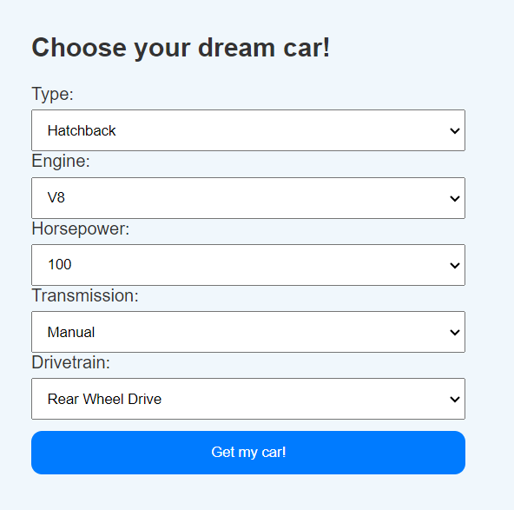

The car menu is simple, with 5 dropdowns for each quality, all having their own unique options that the user can choose from. This is to prevent any errors in data entry, or entering an answer that is not available. After the user has selected all their desired options, they click the “Get my car” button that send them to the next page.

### **Cars Page**

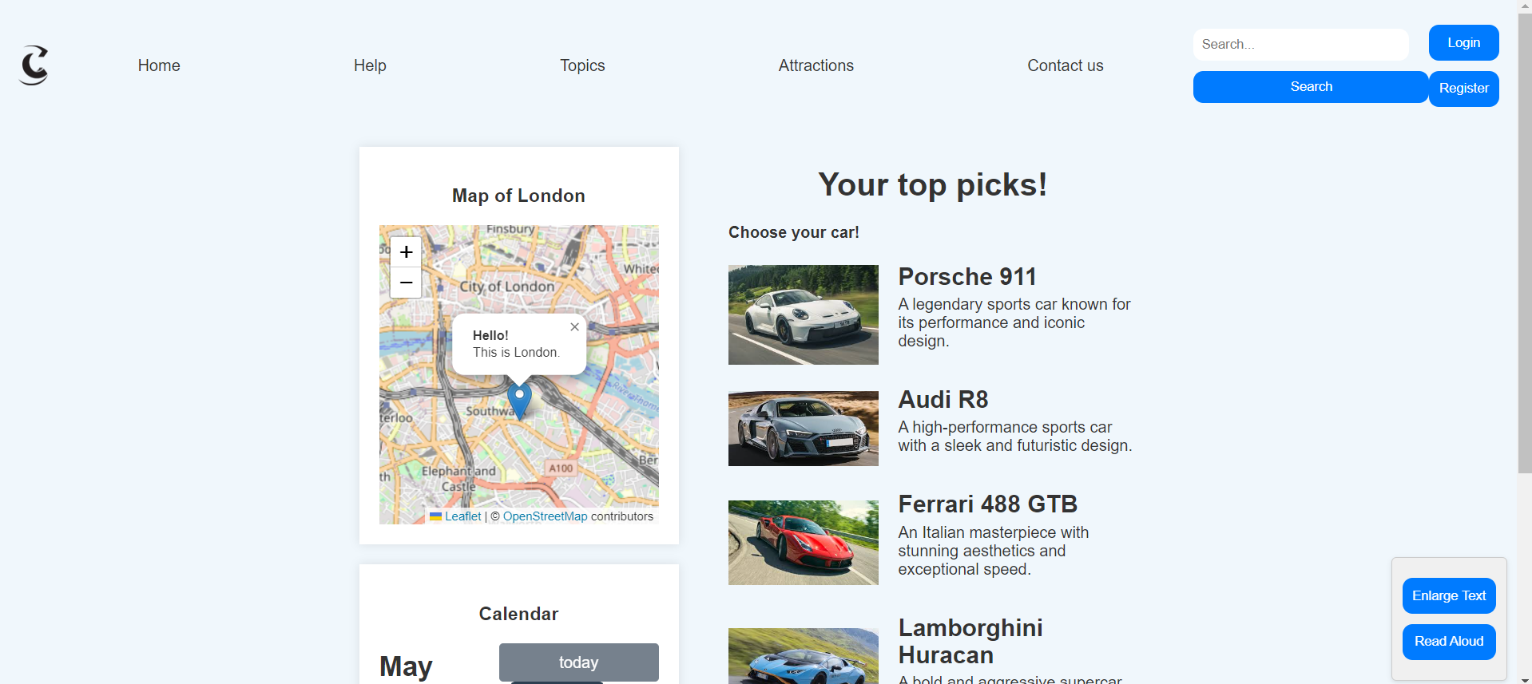The cars page is the third page you are greeted with, with the same map, a calendar but a list of cars this time.

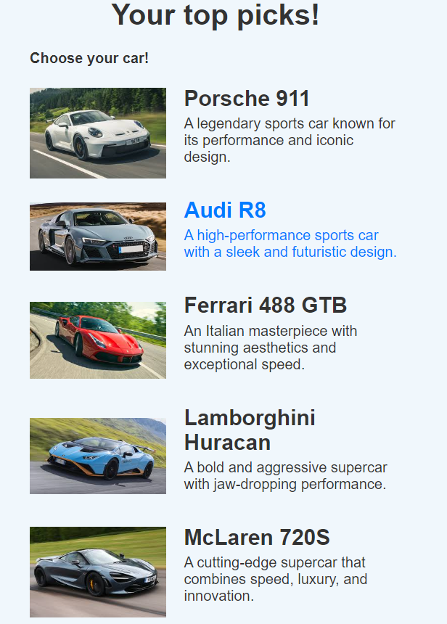

The “cars list” shows a list of cars that are available for the user to try, based on the specifications the user chose. The list mainly makes use of the “Recognition rather than recall” heuristic, with the use of an image to show the user the car in the list. A brief description of the car alongside the name is then shown. When the user selects a car to test drive, they are then taken to the fourth page.

### **Booking Page**

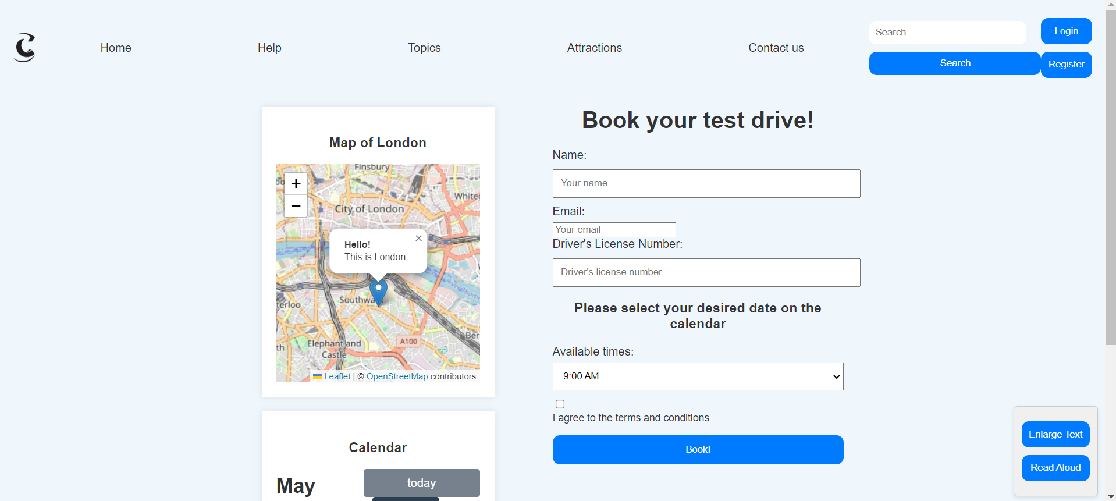

The fourth page the user is greeted with is the booking page, that has the same components and elements as the other two pages, but this time has a booking menu/system for the user to book their test drive.

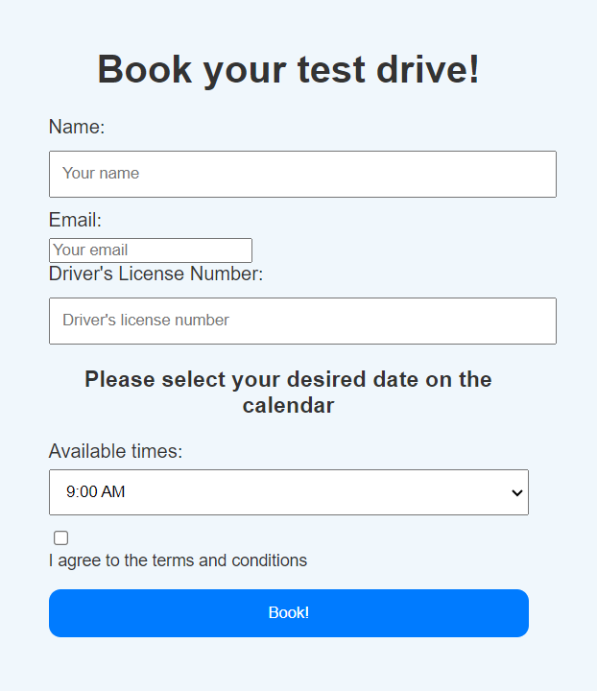

The page incorporates a simple menu system, with text input boxes for the name, email and driver’s license number. The user is required to type these in, with validation checks to ensure that the user has entered their details before they can proceed. The user is then required to pick a date on the calendar, and available times from that date are then shown to the user as the options. The user is then required to check the checkbox saying they have agreed to the terms and conditions of the test drive. After they click “Book!”, the user is then directed to the fifth and final page.

### **Success Page**

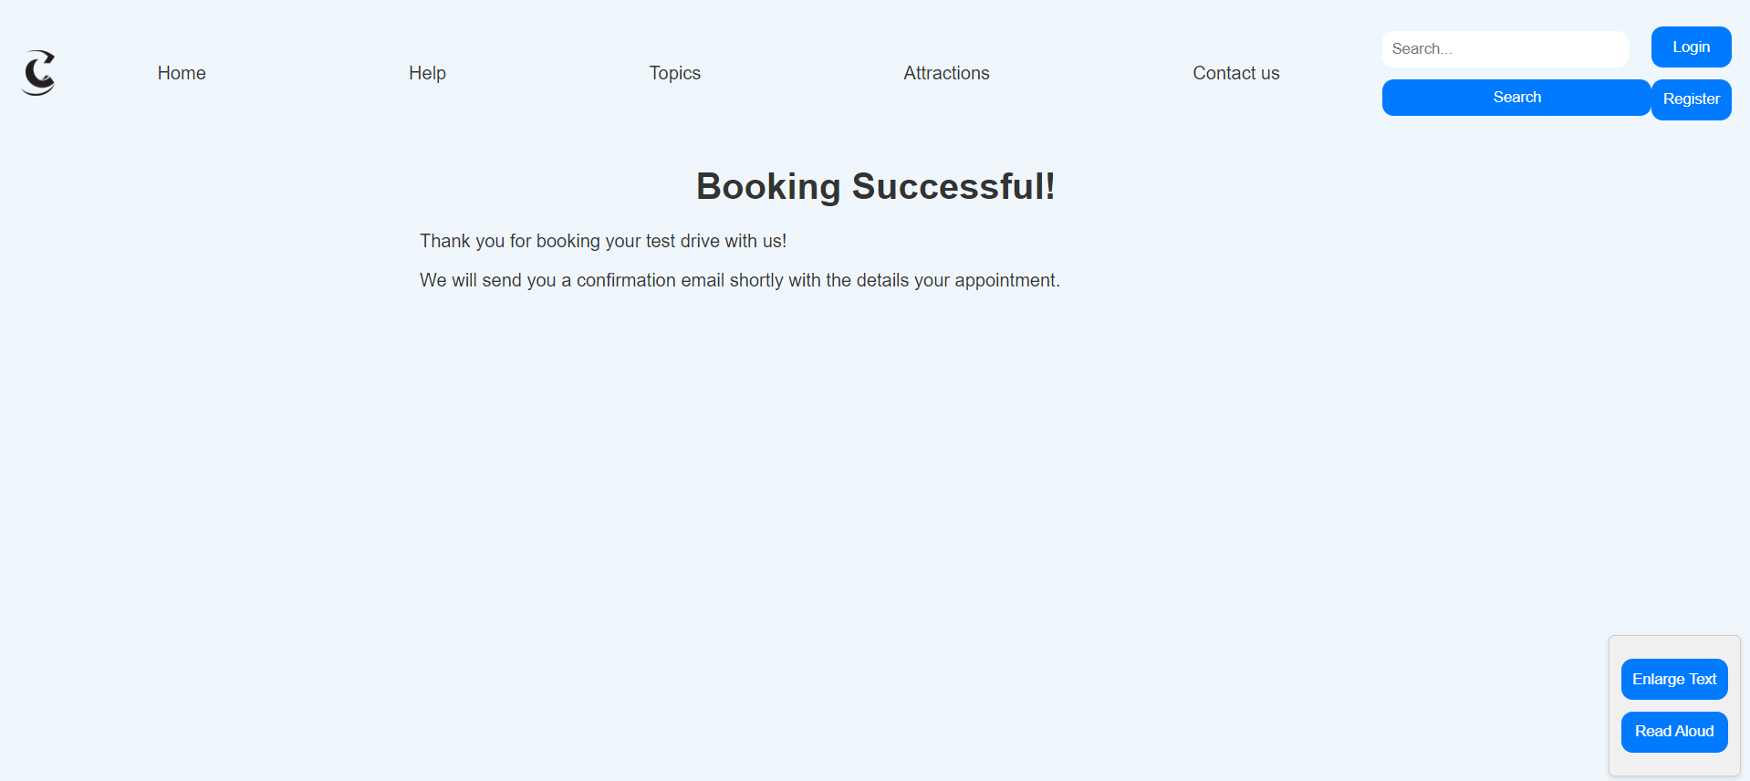

The success page is the fifth and final page of the prototype, and it is just a simple message showing that the booking is successful. A confirmation email is then sent to the user’s email address, with information about the test drive.



## ***Heuristic evaluation and Usability testing***

For this section, I firstly created a Word document with questions I would ask my users. I then asked 5 people to work through my prototype and give me a brief evaluation of their experience while using the system. This involved them looking for aspects of my prototype that they believed supported or did not support Nielson’s 10 heuristics, and give a severity ranking for each. The usability test each of them did, involved them navigating and clicking on any toggles or buttons they could, entering their own data correctly and incorrectly, and generally testing the main features of the prototype. I then asked each of them the questions in my document which were:

“What features did you particularly like while using the prototype?”

“What features did you particularly dislike while using the prototype?”

“What would you improve about the prototype?”

“What elements of the prototype would you say supported or did not support Nielson’s 10 heuristics”

I then asked them to give me a recorded vocal narration of their experience using the system. The results are as follows:

**User 1: Anthony**

**Heuristic Evaluation**

The menu makes use of dropdowns for the user to choose from, which prevents errors. Given a severity ranking of 0 because it is useful to both the system and the user and prevents errors.

The calendar uses a different colour scheme and does not really show consistency in the layout. Given a severity ranking of 1, because it is not a major issue that poses any serious threat.

**Summarised points from usability test**

* Appreciates the use of validation checks to ensure the correct data is entered
* Appreciates the use of the interactive calendar to book the date of the test drive
* Appreciates the menu format, mainly the use of dropdowns for easier usage
* Does not like the format of the calendar, as he thinks the text could be spaced out further.

**User 2: David**

**Heuristic Evaluation**

The booking success page does not actually show the time or date of the booked test drive, so there is no visible indication of the system status. Given a severity ranking of 2, because although it is a major issue, a confirmation email is still sent.

The use of the “Enlarge text” and “Read aloud” buttons are very good, and is a good example of flexibility and efficiency of use. Given a severity ranking of 0, because it is a positive and useful feature to the user.

**Summarised points from usability test**

* Appreciates the use of accessibility features for the disabled
* Would prefer if the map was interactive (at the time it was not)
* Would prefer if the booking page showed the date and time of the test drive, instead of just a success message.

**User 3: Tyrese**

**Heuristic Evaluation**

The use of navigation buttons in the toolbar and around the webpage are good for easy navigation and shows an example of user control and freedom. Given a severity ranking of 0 because it is a positive and useful feature.

The sizing and placements of the menus and elements around the webpage is good and follows a consistent layout. Given a severity ranking of 0 because it a good example of consistency and standards.

**Summarised points from usability test**

* Appreciates sizing of the elements around the webpage
* Appreciates the use of buttons in the toolbar for navigation
* Does not think a toolbar is necessary, and would prefer a separation line to show that it is a toolbar.

**User 4: Fuad**

**Heuristic Evaluation**

The use of pictures alongside the car names allows the user to visually recognise the car, if they cannot recall it by name. Given a severity ranking 0, as it is positive and useful feature.

The design of all the menus are simple, direct and easy understand. This is a good and positive example of aesthetic and minimalist design, and therefore given a severity ranking of 0.

There is no option to go back to the previous page and correct a mistake if one has been made. Given a severity ranking of 3, as this is a critical issue and needs to be corrected before the product release.

**Summarised points from usability test**

* Appreciates the use of pictures in the car list
* Appreciates the very simple and easy design across the website
* Would prefer if there was a button to go back and correct a mistake

**User 5: Victor**

**Heuristic Evaluation**

The text used on buttons throughout the prototype like “Book your test drive!” and “Enlarge text” are clear and concise, and very easy to understand. Given a severity ranking of 0 because this is a good feature.

The “Help” button in the toolbar shows there is available assistance if needed, and is therefore given a severity ranking of 0 for a good example of help and documentation.

**Summarised points from usability test**

* Appreciates the fact that understandable text has been used
* Appreciates the presence of a “Help” toggle in the toolbar
* Would prefer if the map and calendar had descriptions to explain how to use them

## ***Feedback and Discussion***

In general, the evaluation reflects both positive aspects and areas for improvement in the website's design. Addressing concerns such as improving the calendar layout, including the date and time on the booking success page, and adding descriptions for the map and calendar could enhance user experience. However, I do not believe these are serious enough issues of concern, that necessarily require me to change the format of the prototype. In the same vein, where some users criticised the format of a feature in the prototype, other users spoke highly of it.

The one piece of feedback I feel was vital and warranted a change, was the incorporation of a back button to go to the previous webpage after a mistake has been made, to correct any mistakes that would have been made.

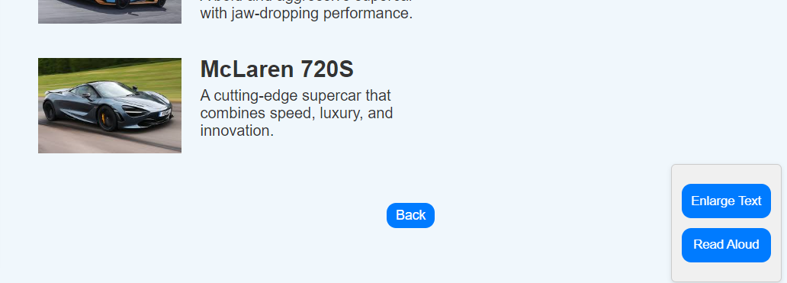

I used this feedback and fixed a critical error in my prototype, and incorporated a back button on each webpage. This allows errors to be fixed easily, and any mistakes to be corrected.

Overall, the evaluation provided valuable insights that guided iterative improvements to the website's design, ensuring better usability and user satisfaction.

## **Conclusion**

Overall, the high fidelity prototype developed for London car enthusiasts is the result of a well-thought-out design and user input. Focusing on usability improvements and including additional features, such as validation checks and accessibility settings, the developed prototype showcases the possibility of creating an appealing and usable platform. While the provided feedback was mixed, including negative assessments of the calendar display and booking success page description, the process of iterative improvement appeared successful in enhancing the general user experience. In the future, additional user testing and refinement would be required to establish the prototype as a sufficient starting point for final development. Adding the potential for an interactive map, polishing the calendar’s designs, and ensuring a thorough explanation of booking confirmation requirements would advance the prototype in its journey towards the final product.